QUESTION:

1.Create a React Application named “cricketapp” with the following components:

React 9:

[ListofPlayers.js](http://listofplayers.js/)

import React from 'react'; const players = [

{ name: "Kane Williamson", score: 100 },

{ name: "Steve Smith", score: 70 },

{ name: "ABD", score: 40 },

{ name: "Joe Root", score: 61 },

{ name: "Conway", score: 61 },

{ name: "Sachin", score: 95 },

{ name: "Dhoni", score: 100 },

{ name: "Virat", score: 84 },

{ name: "Jadeja", score: 64 },

{ name: "Raina", score: 75 },

{ name: "Rohit", score: 80 },

];

export default function ListofPlayers() {

const players70 = players.filter((item) => item.score <= 70);

return (

<div>

<h2>List of Players</h2>

<ul>

{players.map((item, index) => (

<li key={index}>Mr. {item.name}

<span>{item.score}</span></li>

))}

</ul>

<h3>List of Players having Scores Less than 70</h3>

<ul>

{players70.map((item, index) => (

<li key={index}>Mr. {item.name}</li>

))}

</ul>

</div>

);

}

[IndianPlayers.js](http://indianplayers.js/):

import React from 'react';

export function OddPlayers({ players }) {

const [first, , third, , fifth] = players; return (

<div>

<h3>Odd Players</h3>

<ul>

<li>First : {first}</li>

<li>Third : {third}</li>

<li>Fifth : {fifth}</li>

</ul>

</div>

);

}

export function EvenPlayers({ players }) {

const [, second, , fourth, , sixth] = players; return (

<div>

<h3>Even Players</h3>

<ul>

<li>Second : {second}</li>

<li>Fourth : {fourth}</li>

<li>Sixth : {sixth}</li>

</ul>

</div>

);

}

const T20Players = ["First Player","Second Player","Third Player"]; const RanjiTrophyPlayers = ["Fourth Player","Fifth Player","Sixth

Player"];

const IndianPlayersMerged = [...T20Players, ...RanjiTrophyPlayers]; export function IndianPlayers() {

return (

<div>

<h3>List of Indian Players Merged:</h3>

<ul>

{IndianPlayersMerged.map((player, index) => (

<li key={index}>Mr. {player}</li>

))}

</ul>

</div>

);

}

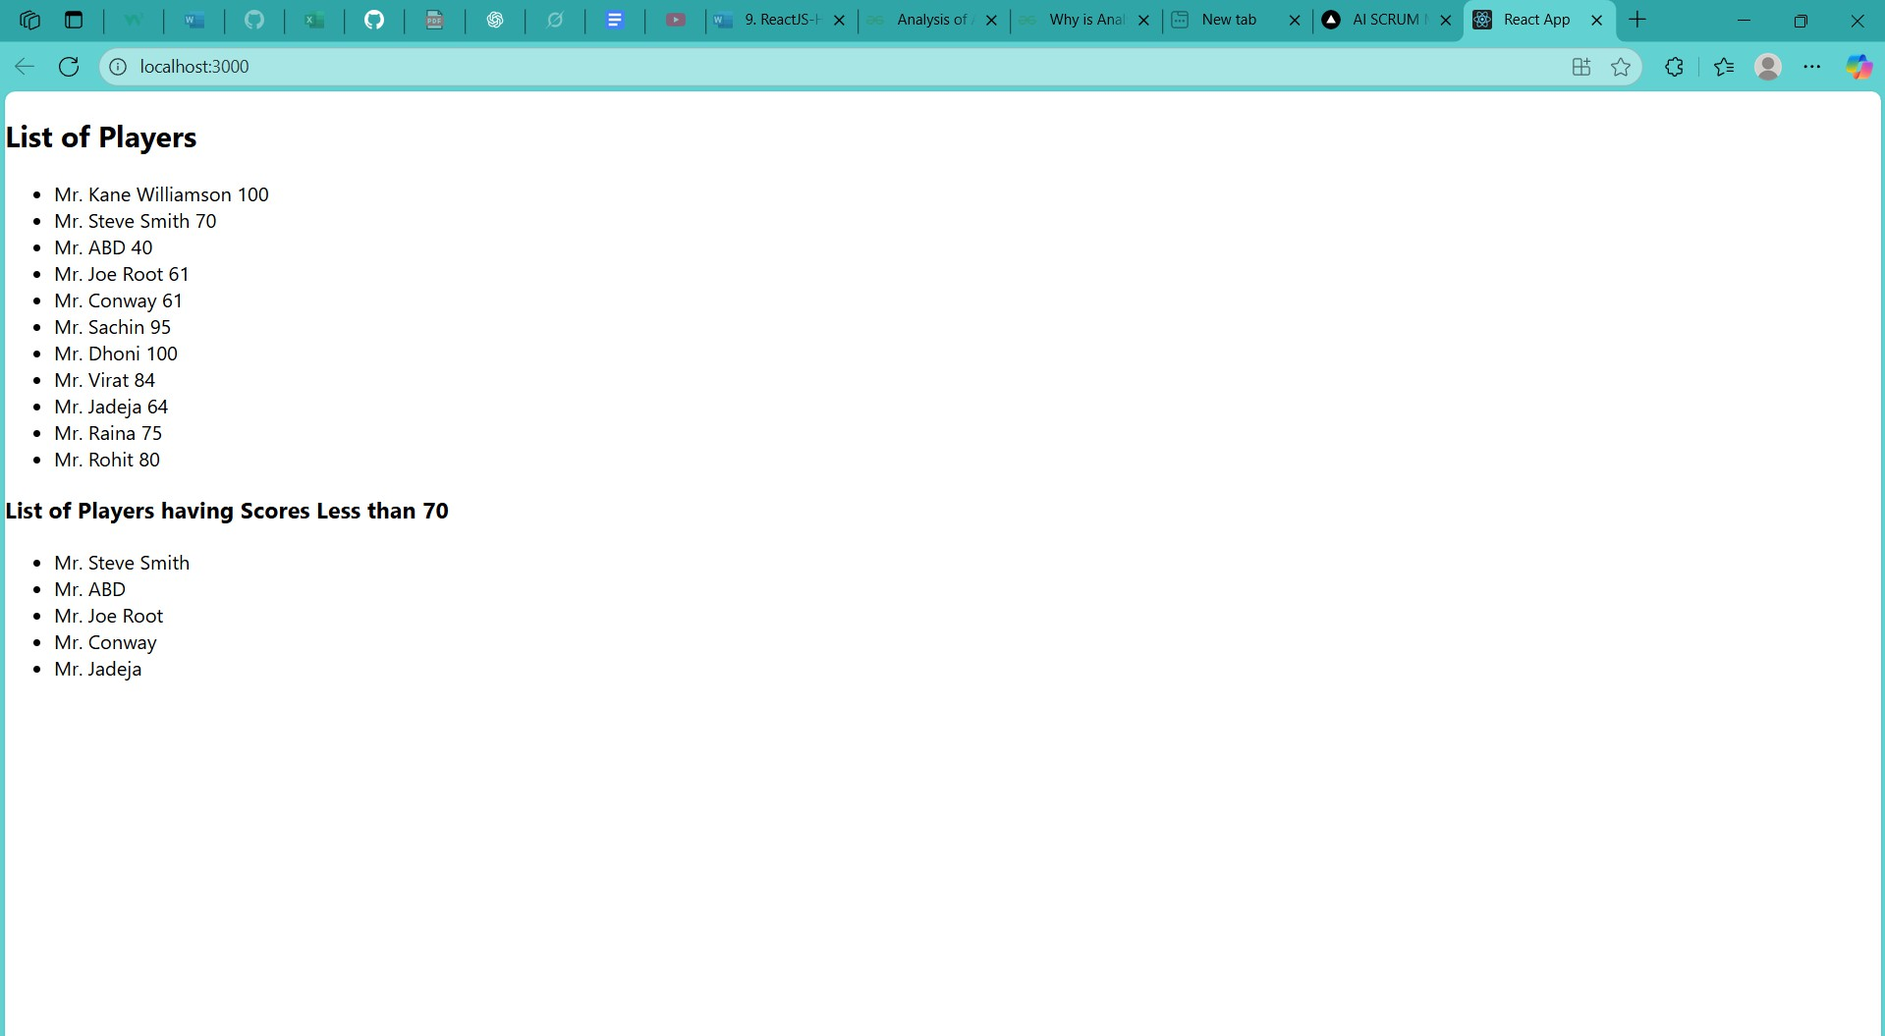[App.js](http://app.js/):

import React from 'react';

import ListofPlayers from './ListofPlayers';

import { OddPlayers, EvenPlayers, IndianPlayers } from './IndianPlayers';

function App() { const flag = true ;

const playersList = ["Sachin1", "Dhoni2", "Virat3", "Rohit4", "Yuvraj5", "Raina6"];

return (

<div className="App">

{flag ? (

<ListofPlayers />

) : (

<>

<OddPlayers players = {playersList} />

<EvenPlayers players = {playersList} />

<IndianPlayers />

</>

)}

</div>

);

}

export default App;

Output:

2.Create a React Application named “officespacerentalapp”

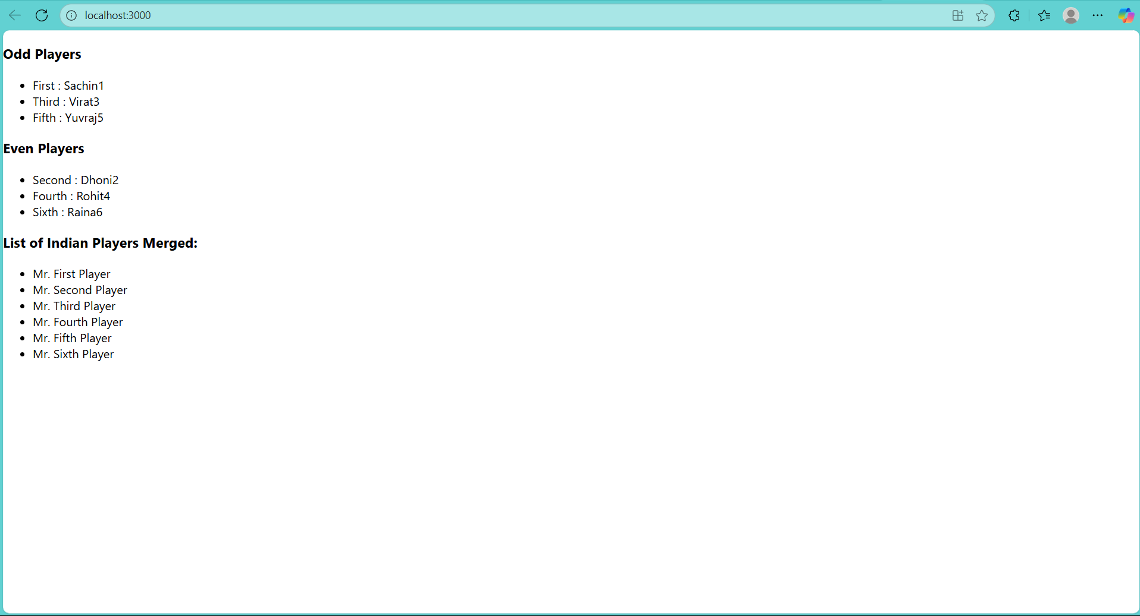**React10:**

[**App.js**](http://app.js/)**:**

import React from 'react';

import './App.css';

import img1 from "./assets/img-1.webp"; import img2 from "./assets/img-2.jpg"; import img3 from "./assets/img-3.webp";

function App() {

const heading = "Office Space"; const officeList = [

**{**

Name: "DBS", Rent: 50000,

Address: "Chennai", Image: img1

**},**

**{**

Name: "ASM Technologies", Rent: 70000,

Address: "Bangalore", Image: img2

**},**

**{**

Name: "Regus", Rent: 35000,

Address: "Mumbai", Image: img3

**}**

**];**

return (

<div className="App">

<h1>{heading} , at Affordable Range</h1>

{officeList.map((item, index) => {

const rentColor = item.Rent <= 60000 ? 'textRed' : 'textGreen'; return (

<div key={index} style={{ marginBottom: "2rem" }}>

<img src={item.Image} width="50%" alt="Office Space" />

<h2>Name: {item.Name}</h2>

<h3 className={rentColor}>Rent: Rs. {item.Rent}</h3>

<h3>Address: {item.Address}</h3>

</div>

**);**

**})}**

</div>

**);**

**}**

export default App;

**App.css:**

.textRed { color: red;

font-weight: bold;

}

.textGreen { color: green;

font-weight: bold;

}

.App {

text-align: center;

font-family: Arial, sans-serif;

}

**Output:**

**3.Create a React Application “eventexamplesapp” to handle various events of the form elements in HTML.**

**React 11:**

[**App.js**](http://app.js/)**:**

import React, { useState } from 'react';

import CurrencyConverter from './CurrencyConverter';

function App() {

const [count, setCount] = useState(0);

function handleIncrement() { setCount(prev => prev + 1); sayHello();

**}**

function handleDecrement() { setCount(prev => prev - 1);

**}**

function sayHello() { alert("Hello Member1");

**}**

function showWelcome(message) { alert(message);

**}**

function handleClick(e) { alert("I was clicked");

console.log("Synthetic event:", e);

**}**

return (

<div style={{ padding: '20px' }}>

<h2>Counter: {count}</h2>

<button onClick={handleIncrement}>Increment</button>

<button onClick={handleDecrement}>Decrement</button>

<br/><br/>

<button onClick={() => showWelcome("Welcome!")}>Say welcome</button>

<br/><br/>

<button onClick={handleClick}>Click on me</button>

<br/><br/>

<CurrencyConverter />

</div>

**);**

**}**

export default App;

[**CurrencyConverter.js**](http://currencyconverter.js/)**:**

import React, { useState } from 'react';

function CurrencyConverter() {

const [amount, setAmount] = useState(''); const [currency, setCurrency] = useState('');

function handleSubmit(e) { e.preventDefault();

if (currency.toLowerCase() === 'euro') { const converted = amount * 80;

alert(`Converting to Euro Amount is ₹${converted}`);

} else if (currency.toLowerCase() === 'rupees') { const converted = amount / 80;

alert(`Converting to Rupees Amount is €${converted}`);

} else {

alert("Unsupported currency. Please type 'euro' or 'rupees'");

**}**

**}**

return (

<div>

<h2 style={{ color: 'green' }}>Currency Converter</h2>

<form onSubmit={handleSubmit}>

<label>Amount: </label>

<input

type="number" value={amount}

onChange={(e) => setAmount(e.target.value)} required

**/>**

<br />

<label>Currency (euro/rupees): </label>

<input

value={currency}

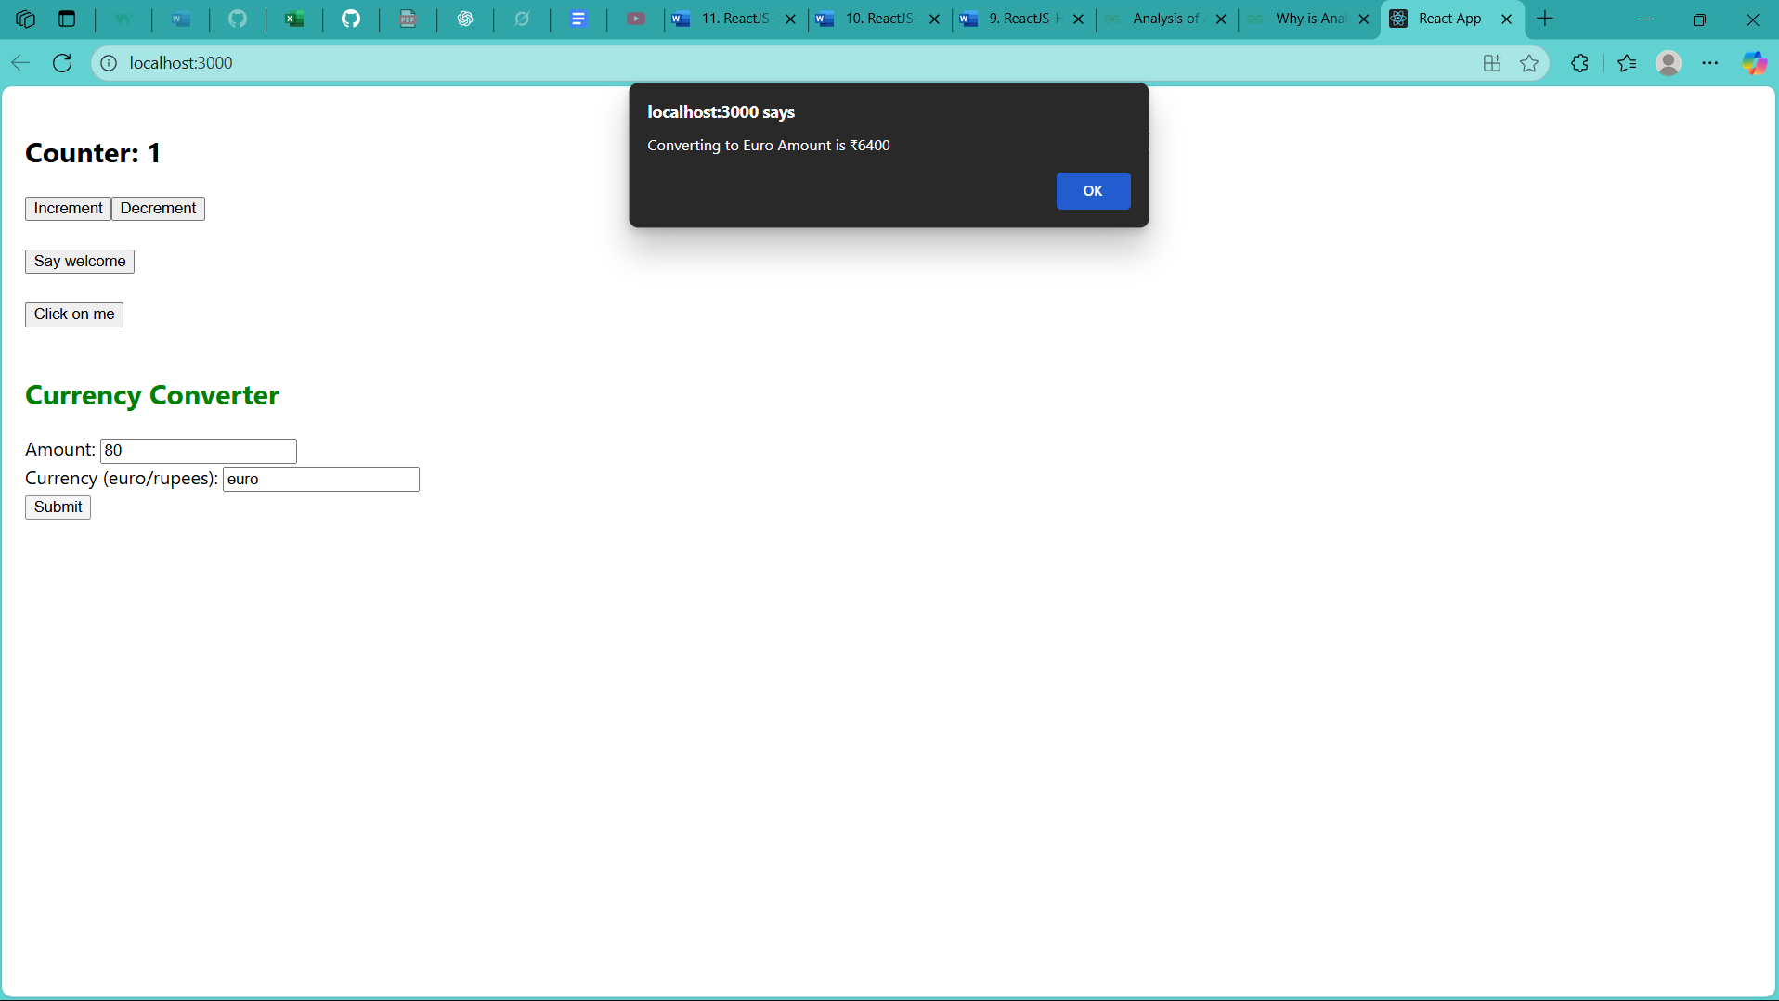

onChange={(e) => setCurrency(e.target.value)} required

**/>**

<br />

<button type="submit">Submit</button>

</form>

</div>

**);**

**}**

export default CurrencyConverter;

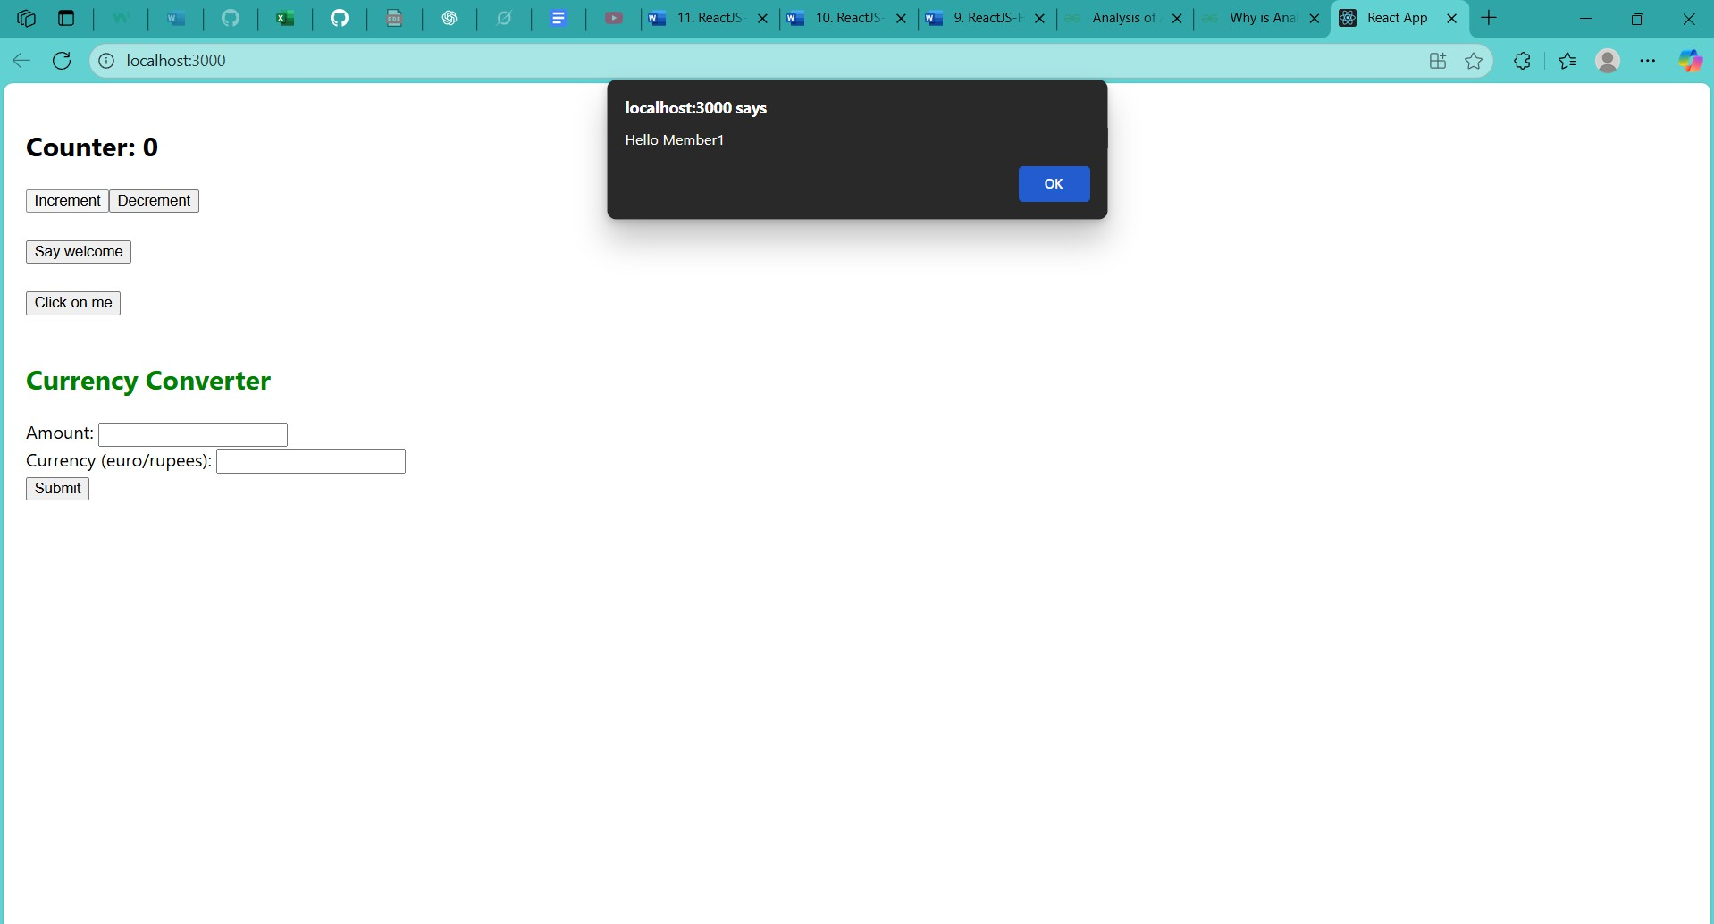**Output:**

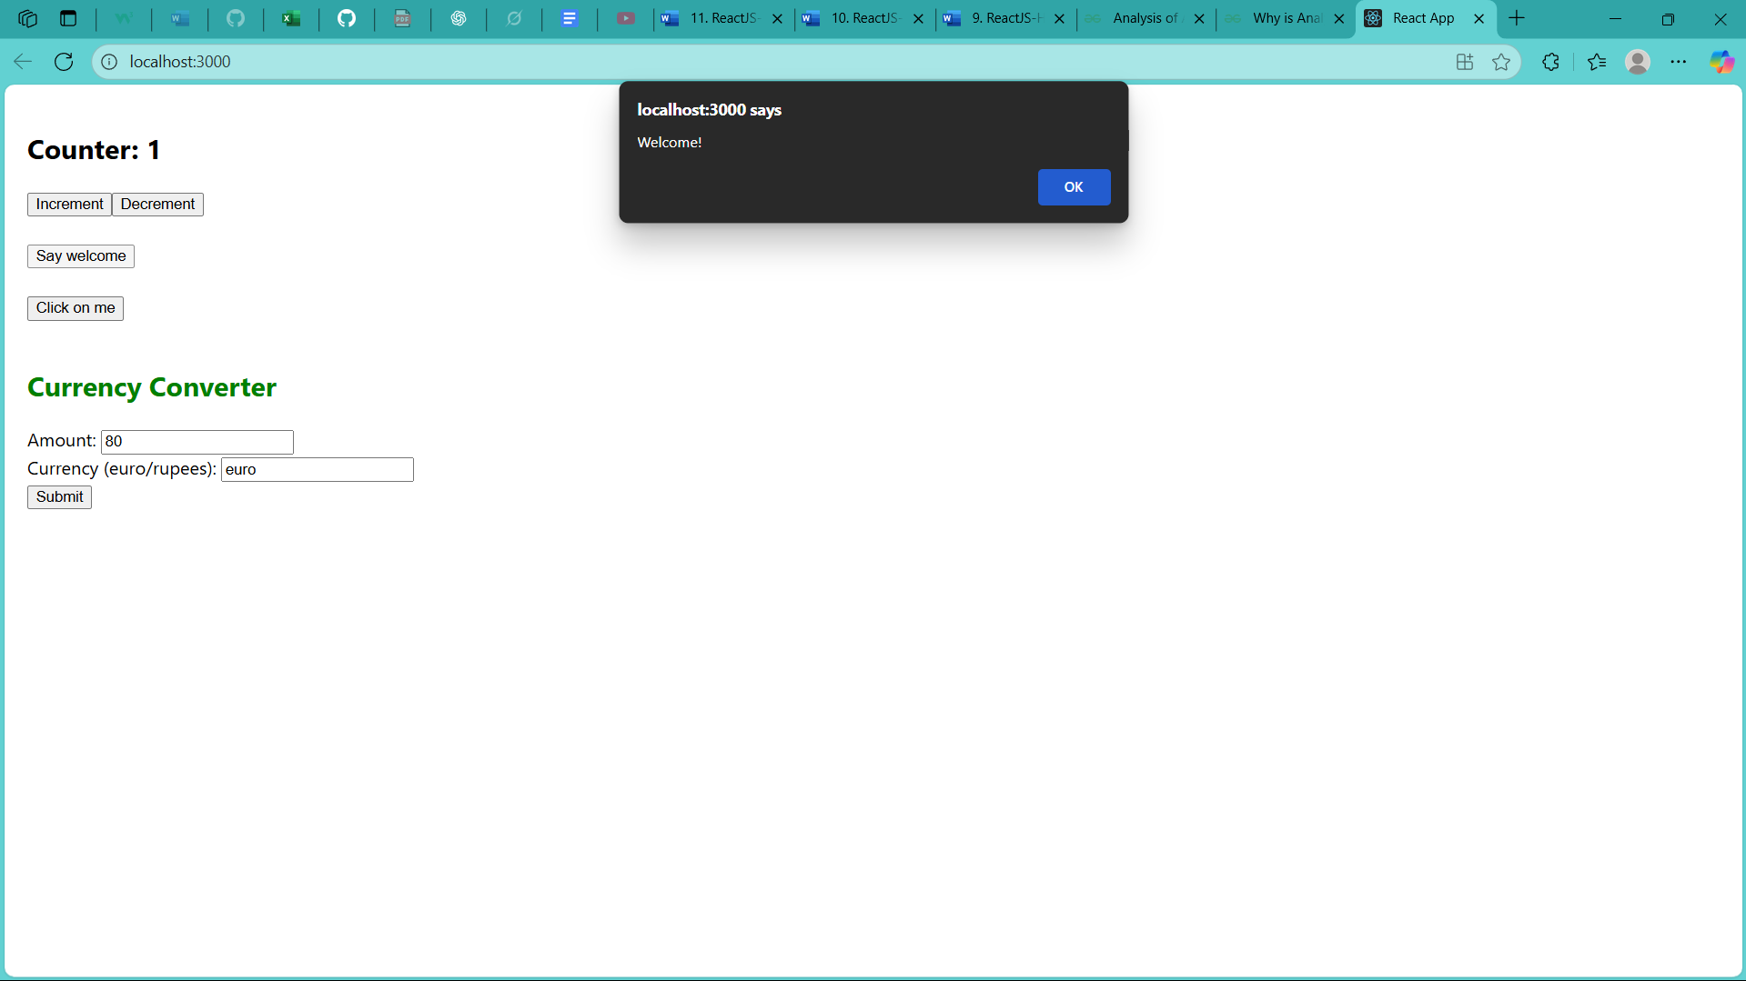

**4.Create a React Application named “ticketbookingapp”**

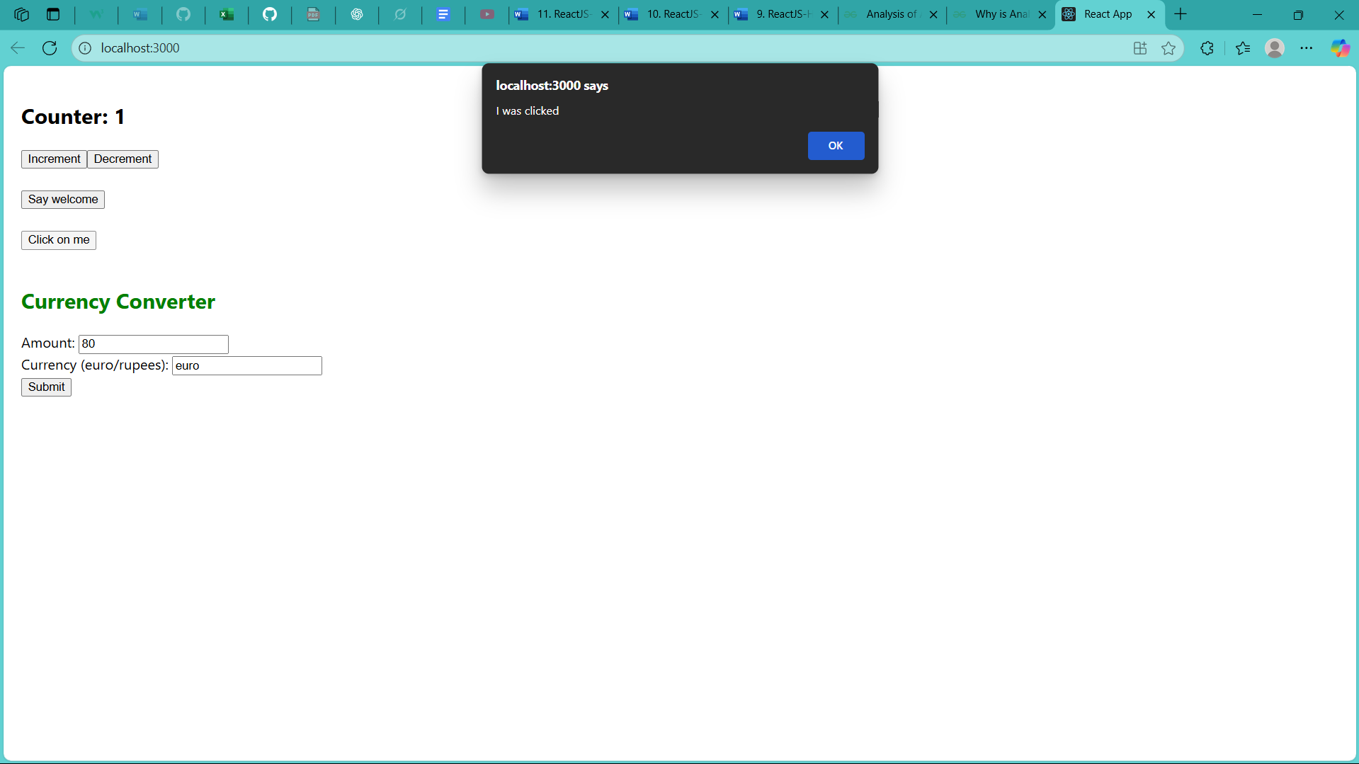**React 12:**

[**App.js**](http://app.js/)**:**

import React, { useState } from 'react';

import './App.css'; function UserGreeting() {

return <h1>Welcome back</h1>;

**}**

function GuestGreeting() {

return <h1>Please sign up.</h1>;

**}**

function Greeting(props) {

const isLoggedIn = props.isLoggedIn; if (isLoggedIn) {

return <UserGreeting />;

**}**

return <GuestGreeting />;

**}**

function LoginButton(props) { return (

<button onClick={props.onClick}> Login

</button>

**);**

**}**

function LogoutButton(props) { return (

<button onClick={props.onClick}> Logout

</button>

**);**

**}**

function LoginControl() {

const [isLoggedIn, setIsLoggedIn] = useState(false); const handleLoginClick = () => {

setIsLoggedIn(true);

**};**

const handleLogoutClick = () => { setIsLoggedIn(false);

**};**

let button;

if (isLoggedIn) {

button = <LogoutButton onClick={handleLogoutClick} />;

} else {

button = <LoginButton onClick={handleLoginClick} />;

**}**

return (

<div>

<Greeting isLoggedIn={isLoggedIn} />

{button}

</div>

**);**

**}**

function App() {

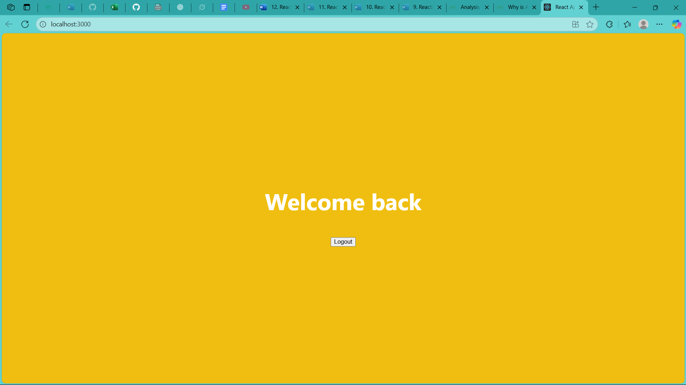

return (

<div className="App">

<header className="App-header">

<LoginControl />

</header>

</div>

**);**

**}**

export default App;

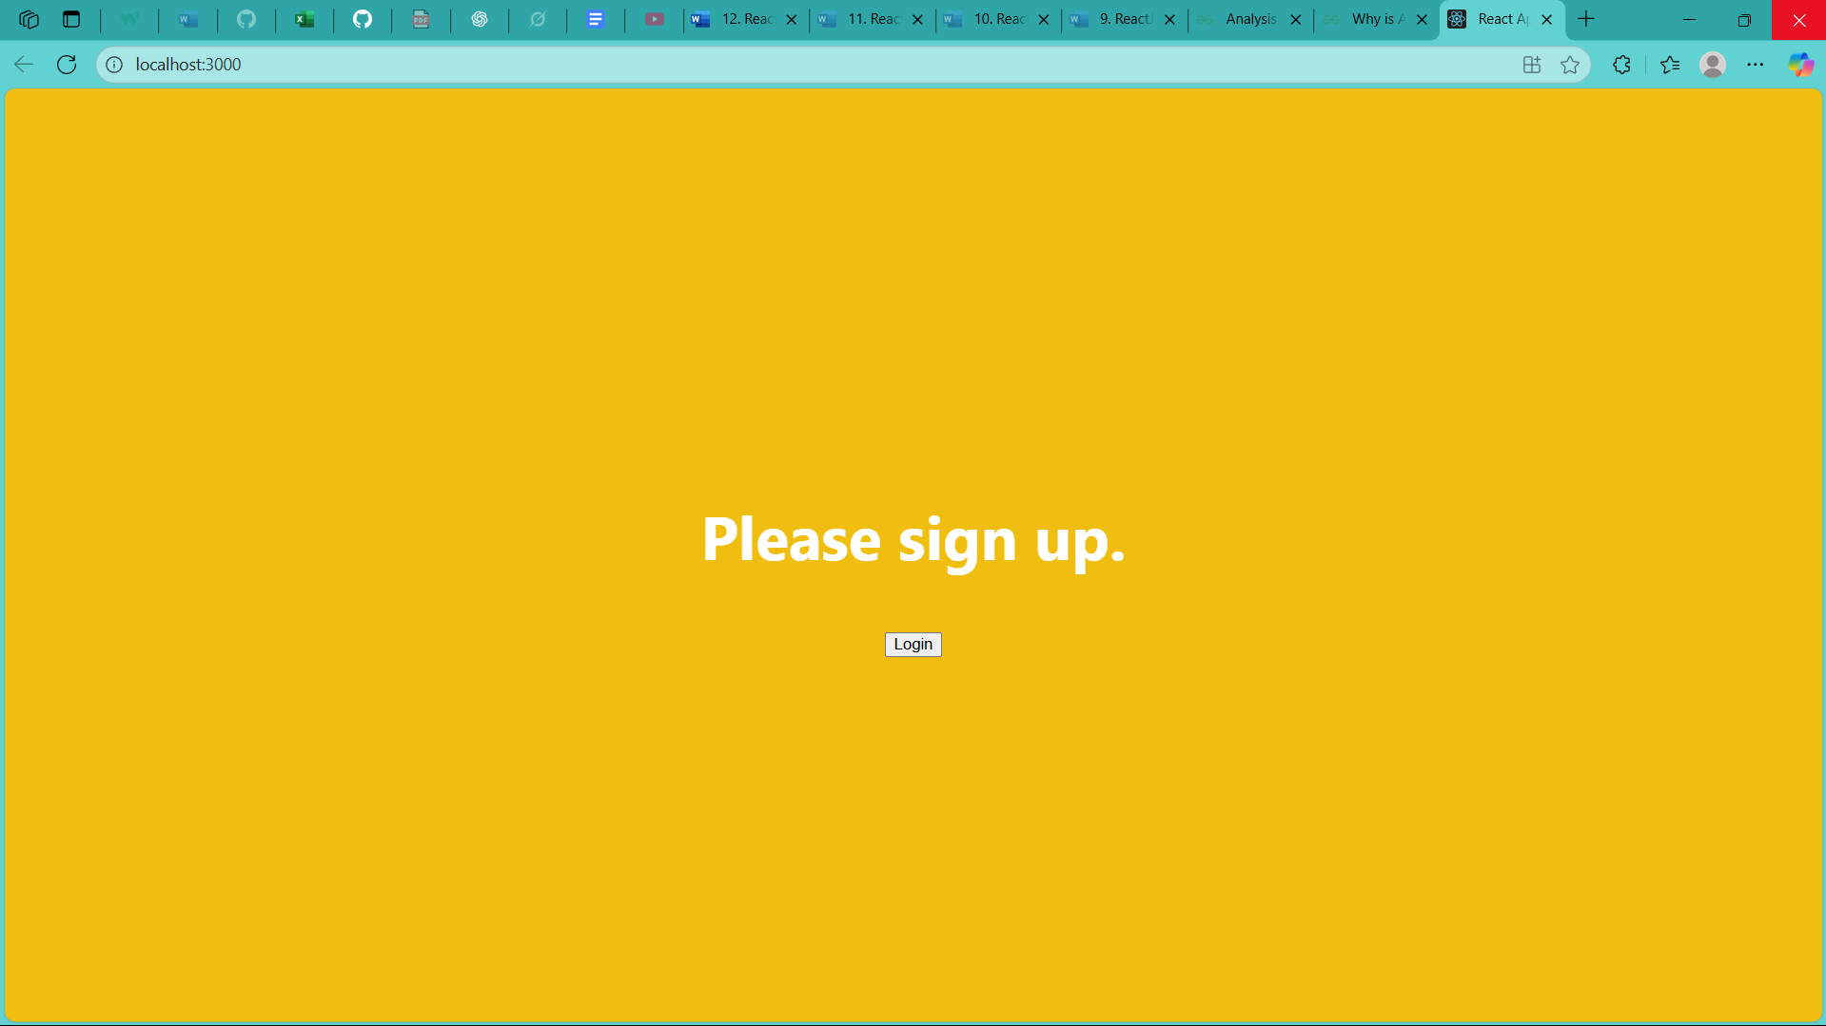**Output:**

**5.** Create a React App named “bloggerapp” in with 3 components.

**React 13:** [**Bookdetails.js**](http://bookdetails.js/)**:**

import React from 'react';

const BookDetails = ({ books }) => { return (

<div className="component-box">

<h2>Book Details</h2>

{books.map((book) => (

<div key={book.id} className="item">

<h3>{book.bname}</h3>

<h4>{book.price}</h4>

</div>

**))}**

</div>

**);**

**};**

export default BookDetails;

[**bookData.js**](http://bookdata.js/)**:**

export const books = [

{ id: 101, bname: 'Master React', price: 670 },

{ id: 102, bname: 'Deep Dive into Angular 11', price: 800 },

{ id: 103, bname: 'Mongo Essentials', price: 450 },

**];**

[**BlogDetails.js**](http://blogdetails.js/)**:**

import React from 'react';

const BlogDetails = ({ blogs }) => { return (

<div className="component-box">

<h2>Blog Details</h2>

{blogs.map((blog) => (

<div key={blog.id} className="item">

<h3>{blog.title}</h3>

<p><strong>{blog.author}</strong></p>

<p>{blog.content}</p>

</div>

**))}**

</div>

**);**

**};**

export default BlogDetails;

**blogData:**

export const blogs = [

**{**

id: 201,

title: 'React Learning', author: 'Stephen Biz',

content: 'Welcome to learning React!'

**},**

**{**

id: 202,

title: 'Installation', author: 'Schwdzdenier',

content: 'You can install React from npm.'

**},**

**];**

[**CourseDetails.js**](http://coursedetails.js/)**:**

import React from 'react';

const CourseDetails = ({ courses }) => { return (

<div className="component-box">

<h2>Course Details</h2>

{courses.map((course) => (

<div key={course.id} className="item">

<h3>{course.name}</h3>

<p>{course.date}</p>

</div>

**))}**

</div>

**);**

**};**

export default CourseDetails;

[**courseData.js**](http://coursedata.js/)**:**

export const courses = [

{ id: 301, name: 'Angular', date: '4/5/2021' },

{ id: 302, name: 'React', date: '6/3/20201' },

**];**

[**App.js**](http://app.js/)**:**

import React, { useState } from 'react';

import BookDetails from './components/BookDetails'; import BlogDetails from './components/BlogDetails'; import CourseDetails from './components/CourseDetails'; import { books } from './data/bookData';

import { blogs } from './data/blogData'; import { courses } from './data/courseData'; import './App.css';

function App() {

const [view, setView] = useState('all'); const renderCourseDetails = () => {

if (view === 'all' || view === 'courses') { return <CourseDetails courses={courses} />;

} else {

return <div className="placeholder">Courses are hidden</div>;

**}**

**};**

return (

<div className="App">

<h1>Blogger App</h1>

<p>Demonstrating Conditional Rendering</p>

<div className="controls">

<button onClick={() => setView('all')}>Show All</button>

<button onClick={() => setView('books')}>Show Only Books</button>

<button onClick={() => setView('blogs')}>Show Only Blogs</button>

<button onClick={() => setView('courses')}>Show Only Courses</button>

</div>

<div className="content-container">

{view === 'all' || view === 'books' ? (

<BookDetails books={books} />

**) : (**

<div className="placeholder">Book Details are hidden</div>

**)}**

{(view === 'all' || view === 'blogs') && <BlogDetails blogs={blogs} />}

{view !== 'all' && view !== 'blogs' && (

<div className="placeholder">Blog Details are hidden</div>

**)}**

{renderCourseDetails()}

</div>

</div>

**);**

**}**

export default App;

**Outputs:**

